Grid Pane added, Grid Lines Visible checked, file then saved.
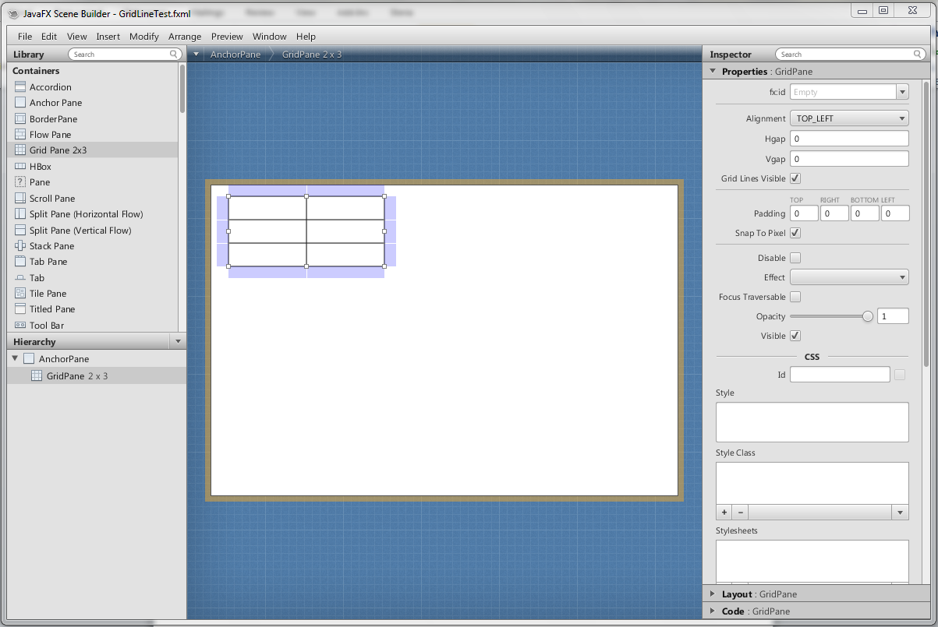

Upon reloading the file Grid Lines Visible is unchecked.
