Failed application on 8u121 launched on Secondary screen
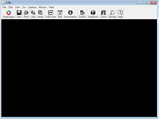
Note blank 3270 Terminal Emulator screen

Functioning application on 8u121 launched on Primary Screen
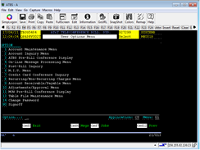
Application functioning as expected.

Failed application on either primary or secondary using 8u152
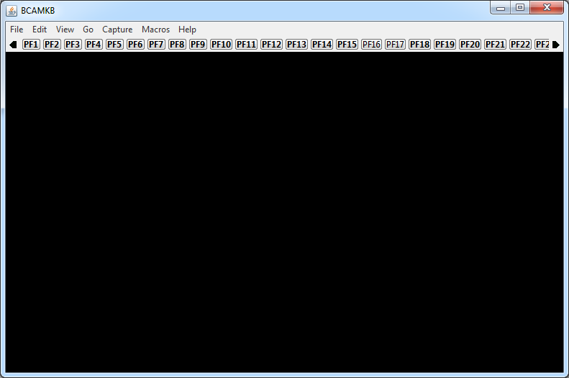
Note that pf* swing/AWT buttons in toolbar were created, unlike 8u121 failure.

