ENH 31987367 - PSR:DIAG:JMC JMC7 Bring back Samples Percentages per Thread
Reference screen from JMC 5.5 for Hot Threads
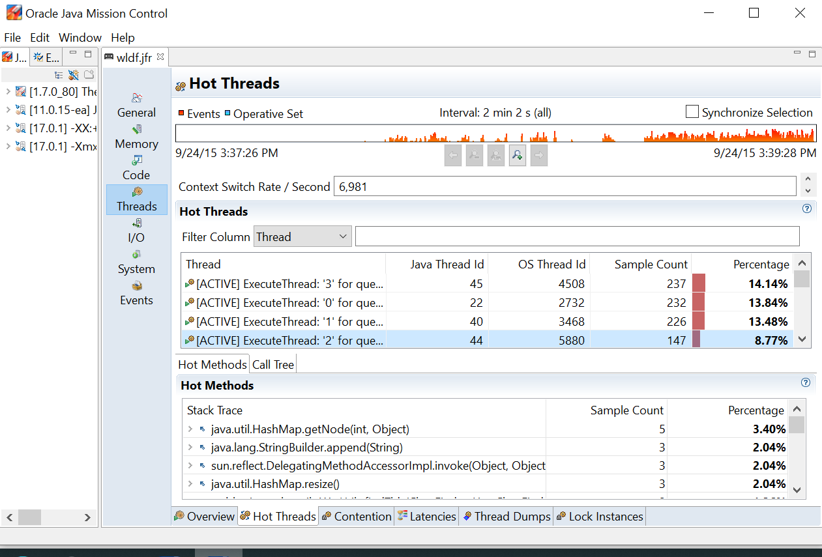

Recent JMC releases:
Select ‘Java Application’ in outline.
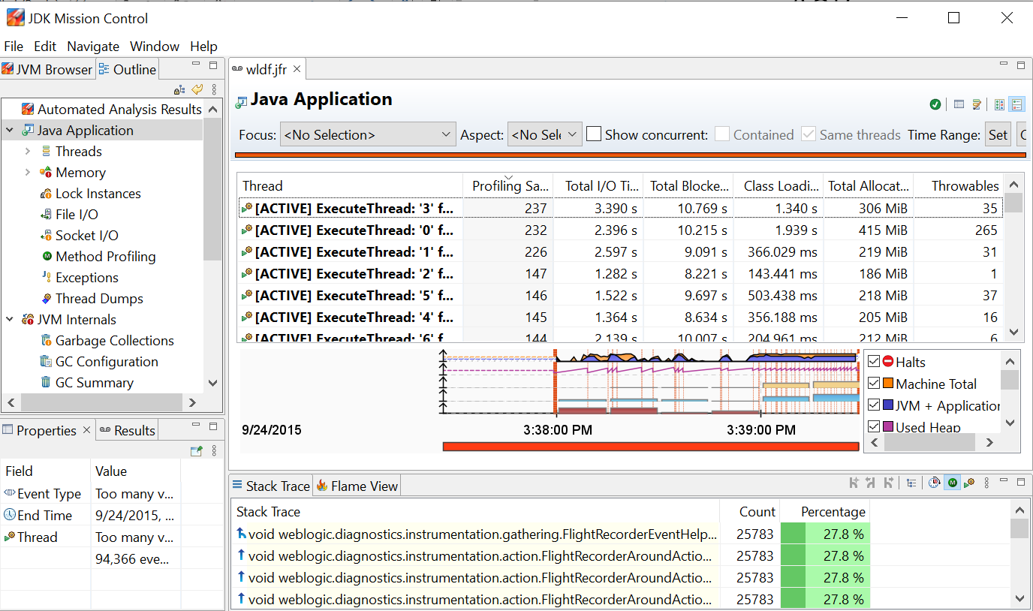
Columns visible in table are the default columns. Users can either show or hide the columns based on their needs and these changes will be stored. From next launch onwards these columns will be shown.
Right click on the table then use ‘Visible Columns’ and select ‘Percentage’.
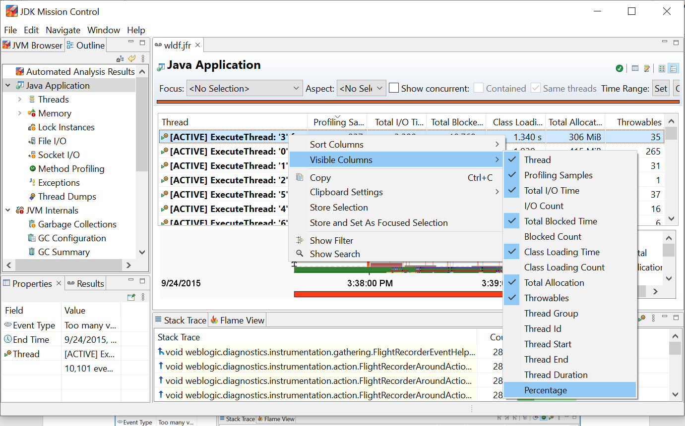

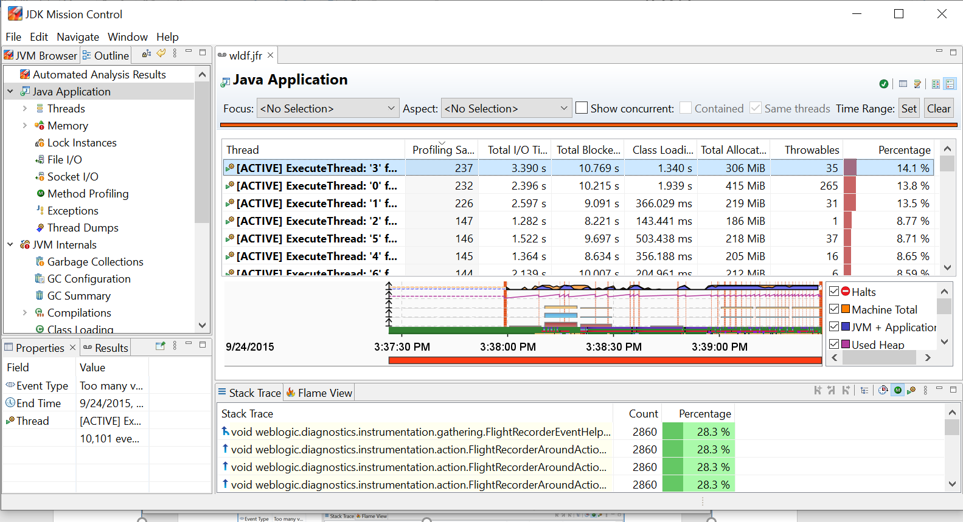

Users can hide extra columns and show the desired columns in the table. Please refer the below screen shot where the table has only few columns and looks similar as JMC 5.5.
